**MDC MG2MDCCSC101**

**MASTERING SPREADSHEETS**

**RECORD QUESTIONS**

|  |  |
| --- | --- |
| **SL.NO** | **EXPERIMENTS** |
|  | Basic spreadsheet skills :  Create a simple spreadsheet including various types  of data,format cells,use basic functions like autosum and apply conditional formatting to highlight important information. |
|  | Formula and functions:  Create a spreadsheet and apply formula and functions for data computation (Mathematical,statistical,  text,financial,and data functions) |
|  | Data visualization with charts:  Explore different types of charts to represent data by adjusting elements for clarity and impact. |
|  | Pivot table analysis:  Create a pivot table to analyze data ,explore different dimensions, and summarize information using calculated fields. |
|  |  |

Answers

Q1) 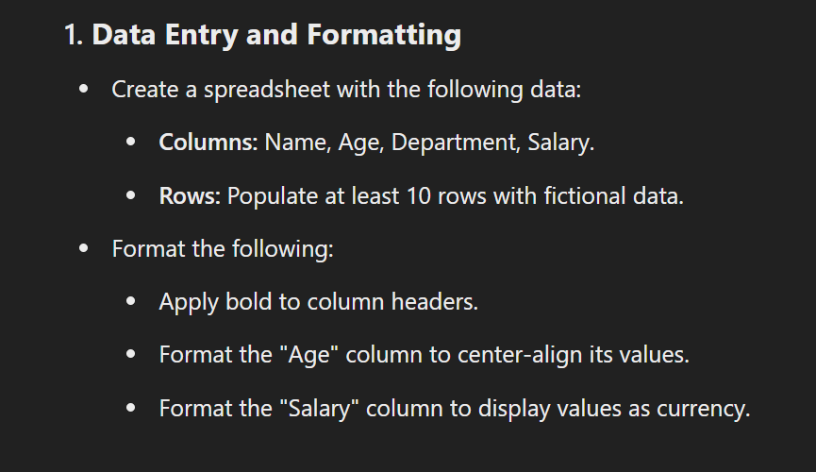

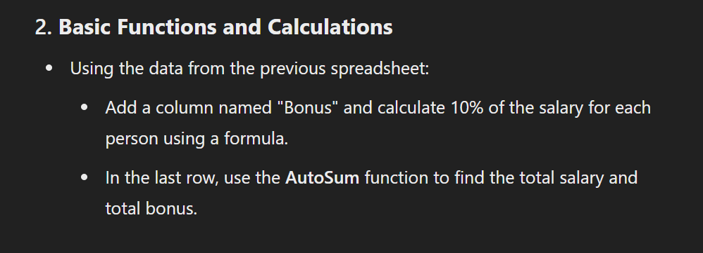

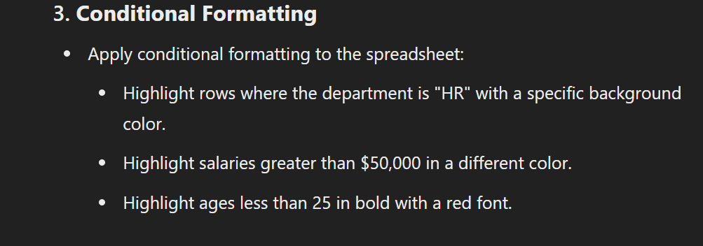

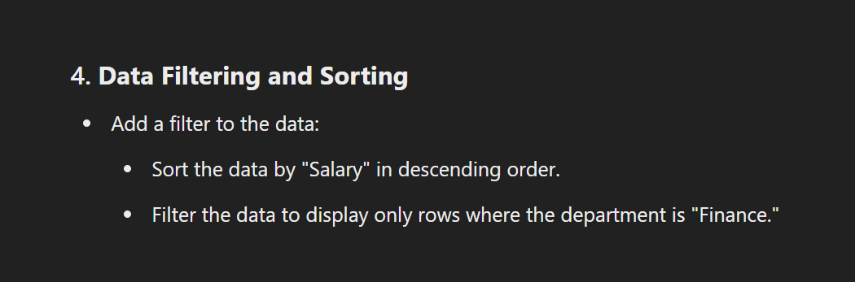

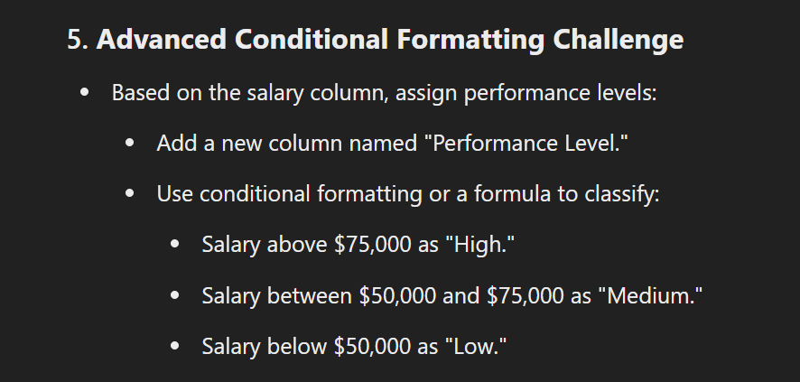

**Question for students**

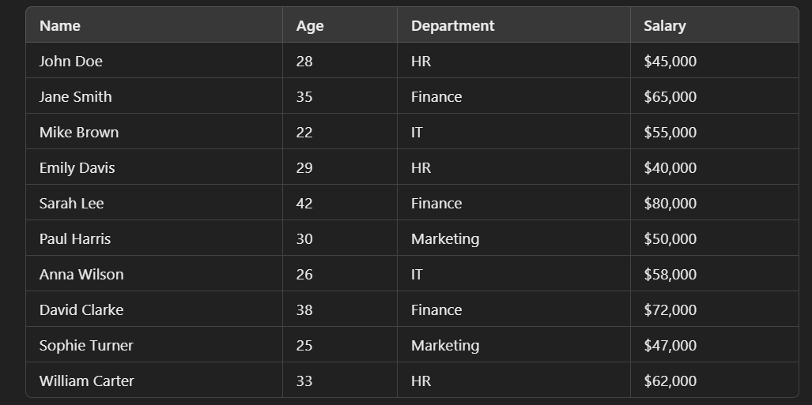

**Answer**

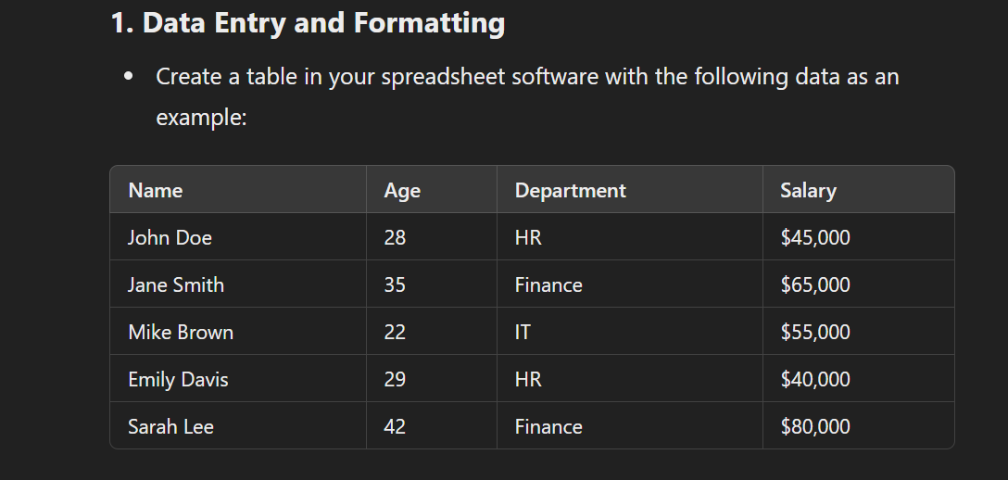

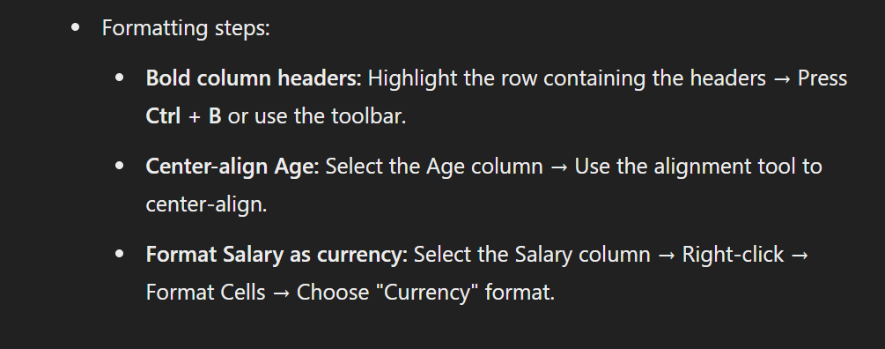

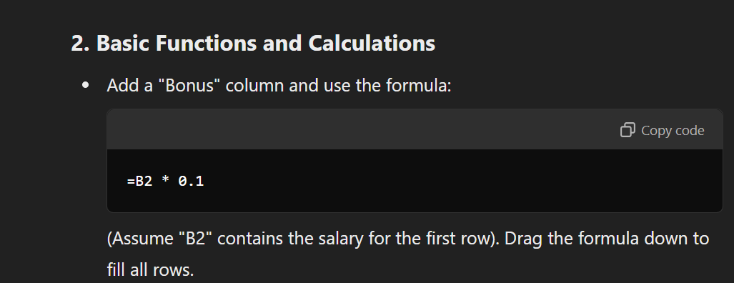

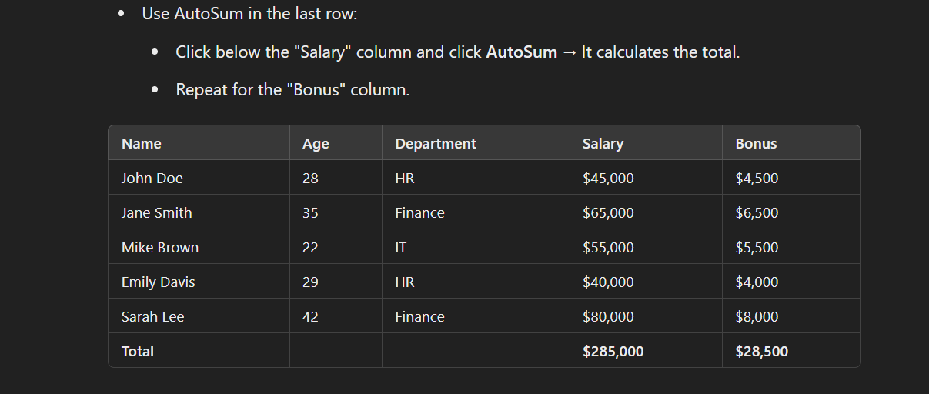

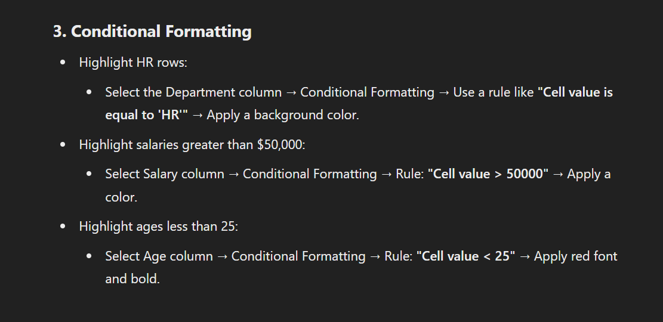

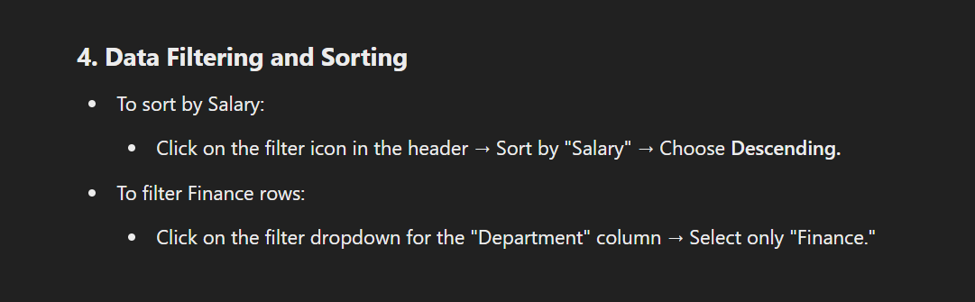

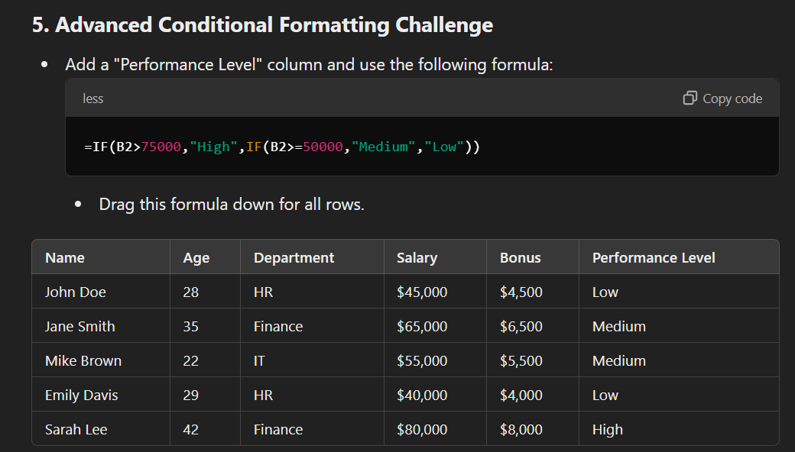

**Q2**

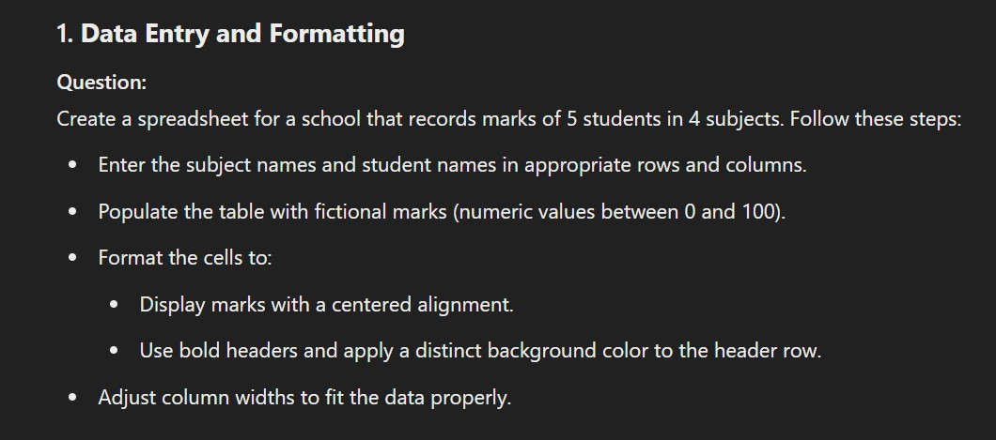

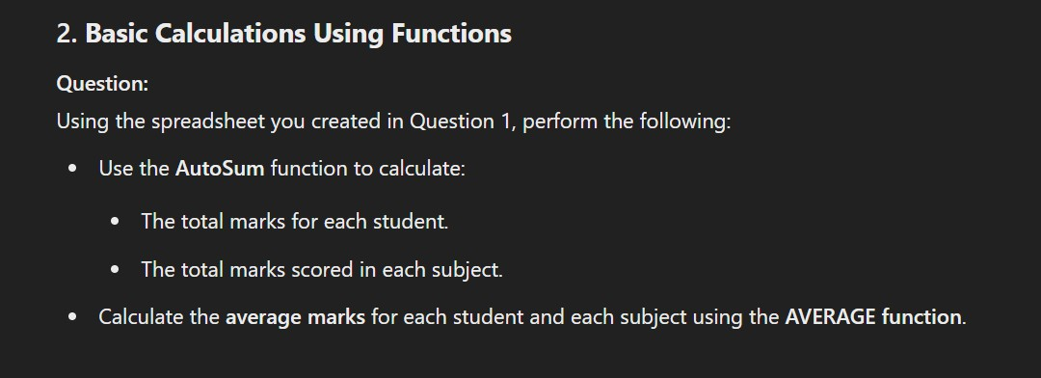

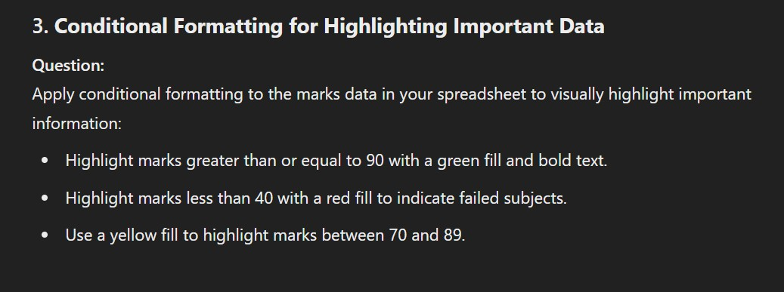

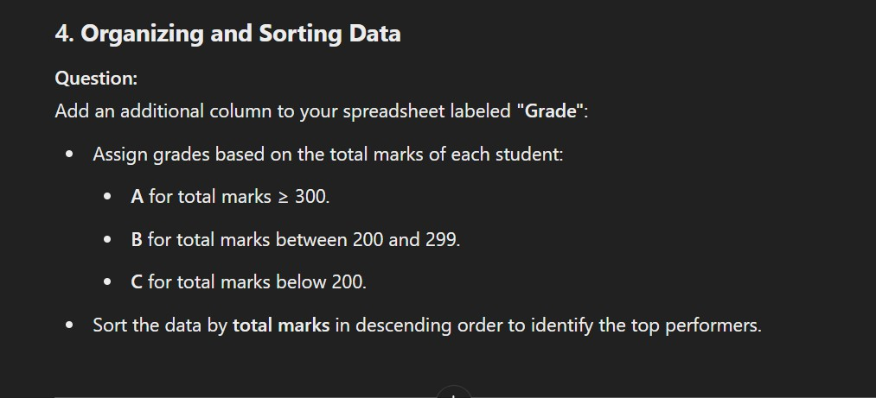

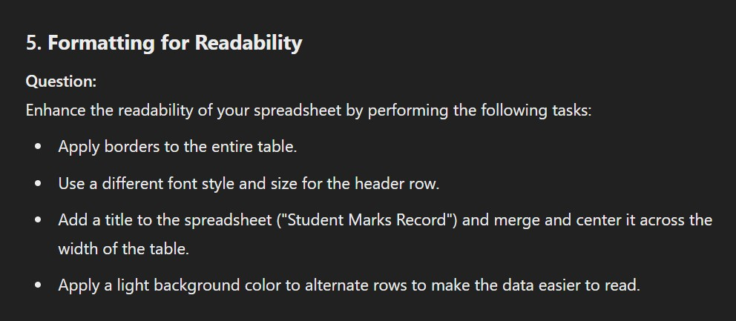

**Answer**

